Query the list of CITY names ending with vowels (a, e, i, o, u) from **STATION**. Your result cannot contain duplicates.

**Input Format**

The **STATION** table is described as follows:

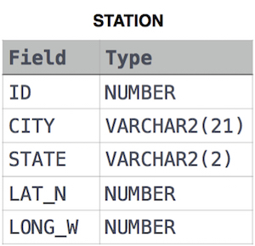

where LAT_N is the northern latitude and LONG_W is the western longitude.

Ans:

select distinct CITY from STATION where

CITY like '%a' or

CITY like '%e' or

CITY like '%i' or

CITY like '%o' or

CITY like '%u';